**Bachelor of Engineering (Honours) in Software and Electronic Engineering**

**GMIT Department of Electrical and Electronic Engineering**

**Year 1**

**Industrial Automation**

**Gabriel Farragher 2022**

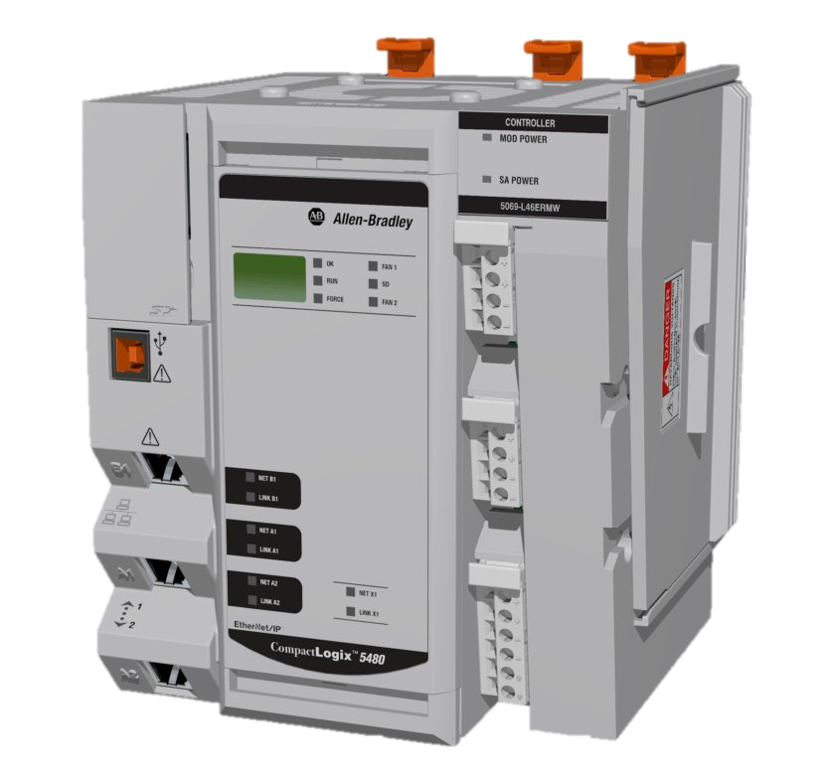

# Student Details:

* Date: January – April 2022
* Module: Industrial Automation
* Student Name:
* Student Number:
* Lecturer: Gabriel Farragher
* Document: Lab Reports

# Table of Contents:

1 Student Details: 2

2 Table of Contents: 3

3 Table of Figures: 3

4 Lab 5 Structured Text ST 1: 5

4.1 Structured Text Introduction: 5

4.2 The IEC 61131-3 Languages: 5

4.3 Why use Structured Text ST: 6

4.4 Structured Text Exercise 1: 8

4.5 Structured Text Exercise 2: 8

4.6 Structured Text Exercise 3: 10

4.7 Structured Text Exercise 4: 11

# Table of Figures:

No table of figures entries found.

**Notes:**

|  |
| --- |
|  |
|  |
|  |
|  |
|  |
|  |
|  |
|  |
|  |
|  |
|  |
|  |
|  |
|  |
|  |
|  |
|  |
|  |
|  |
|  |

# Lab 5 Structured Text ST 1:

## Structured Text Introduction:

* Structured Text is PLC programming language which is part of IEC 61131-3.
* The programming language is text-based, compared to the graphics-based such as Ladder Diagram LD or Function Block Diagram FBD.
* By using a text-based PLC programming language, your program will take up much smaller space, and the flow/logic will be easier to read and understand.
* You can for example scale a PLC analog input or output with just one line of code or set an alarm for your SCADA system solution.
* The syntax of Structured Text ST is developed to look like the syntax of a high-level programming language with loops, variables, conditions, and operators.
* Structured Text ST is like C programming, Basic or Pascal Programming. This is a high-level structured text language which allows conditional execution using IF THEN, and ELSE statements.
* Easily define arithmetic and comparison operations, which can be difficult using instruction list and ladder diagram, making it easier for the user to understand the program.

## The IEC 61131-3 Languages:

* Ladder Diagram (LD), graphical
* Function Block Diagram (FBD), graphical
* Structured Text (ST), textual
* Instruction List (IL), textual [Not used anymore and will be officially removed in 2022]
* Sequential Function Chart (SFC) has elements to organize programs for sequential and parallel control processing, graphical.

Image Source: MotionControlTips.com

* Control Engineering survey indicated that of all the possible IEC61131 PLC defined languages, Structured Text has seen the greatest increase in adoption. Processes are becoming more complex therefore, ttrigonometry, calculus, and data analysis can be implemented far easier in this language than in Ladder or FBD.
* Structured Text is the easiest language to copy from one platform into another. This makes it very flexible. ST can be shared via a notepad text file or email.

## Why use Structured Text ST:

* Speed of execution by the PLC. Runs and executes much faster than Ladder Logic. (Useful in controlling motion applications e.g., Servo Motor Commands).
* Ease of implementing complex mathematical operations.
* It will enable you to cover some instructions that are not available in some other languages like the Ladder Diagram.
* I.T. and Computer Programmers are familiar with C, Pascal and other computer programming languages and learn Structured Text quicker than Ladder Logic or Function Block Diagrams as ST is similar.
* Students currently graduating from engineering studies have a better background in computer languages than in the basics of electrical wiring, and therefore can more easily become proficient in ST than Ladder programming.

Here is a simple example:

* Ladder Logic LD:



* Now in Structured Text ST:
* Y001 := X001; (*When Switch 1 is High/On then Y001 High/On*)
* The output is first then the input as shown above. Note the green text is used for commenting each line of code. Start with a bracket and then the star sign and end with a star and closed bracket as shown above. This is very important for larger more complex programs otherwise it would be very difficult for a person to follow another person’s code.

## Structured Text Exercise 1:

**Using GX Works 2 copy the following Structured Text ST code and test using the available simulator. Comments are included in the program.**

Y1 := (X1 OR Y1) AND X002; (* When X1 is On and X2 is On, Y1 is On and Held On *)

Y2 := X003 AND X004; (* When X3 is On and X4 is On, Y2 is On and Held On *)

Y3 := X3 AND X5; (* When X3 is On and X5 is On, Y3 is On and Held On *)

Y4 := (X6 OR Y004) AND NOT X001; (* When X0 is turned On and Not X1, Y0 switches On and is held On due to Hold-On Contact *)

* **Note: Save PLC software file as: GX W2 L5 Ex 1 GF A**

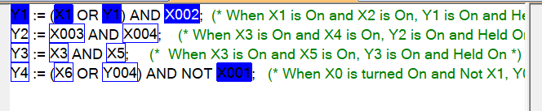

## Structured Text Exercise 2:

**Input the following ST into GX Works 2 and use simulation to answer the following questions.**

IF X001 THEN

D2 := 5; (* When X1 is turned On, the Constant 5 is moved into Data Register D2 *)

END_IF;

IF X002 THEN

D2 := D2 + 1; (* When X2 is turned On, D2 will increment based on the Scan Cycle by the value of 1 (Ensure X1 is OFF) *)

END_IF;

* **Note: Save PLC software file as: GX W2 L5 Ex 2 GF A**

**A): What Happens when X1 is switched On?**

|  |
| --- |
| D2 is 5 |

**B): What happens when X1 is switched Off?**

|  |
| --- |
| **D2 remains 5** |

**C): Turn X1 back On, what happens when X2 is turned On?**

|  |
| --- |
| **D2 becomes 6** |

**D): Ensure X1 is Off and turn On X2. Explain what is occurring with PLC program.**

|  |
| --- |
| **D2 increments** |

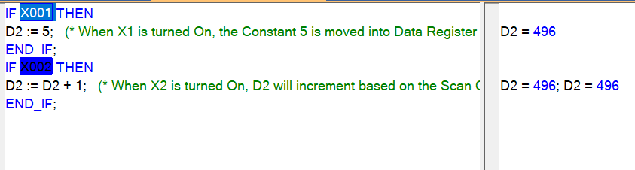

## Structured Text Exercise 3:

An analog temperature Wall Stat is used to control a contactor which turns on a Heater. Using Structured Text ST write the code so that if:

* The Temperature is below 18 (degrees) the Heater is On.
* The Temperature is above 18 (degrees) the Heater is Off.
* [IF THEN ELSE function will help for this exercise].

**I/O List:**

* Wall Stat – wWallStat [Local Variable of Data Type **Word**]
* Heater – bHeater [Local Variable of Data Type **Bit**]
* **Note: Save PLC software file as: GX W2 L5 Ex 3 GF A**

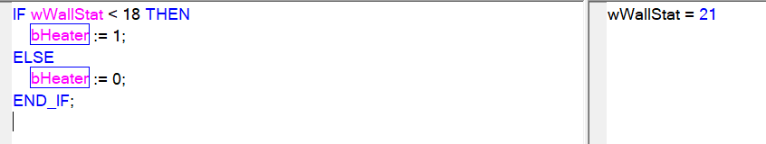

## Structured Text Exercise 4:

An automated process fills can of paint, weights them and at the end of the process labels are added.

* If the Paint weight is from 0 – 20 then its Product 1.
* If the Paint weight is from 21 – 30 then its Product 2.
* If the Paint weight is from 31 – 40 then its Product 3.
* Any other weight - Product 4.
* [CASE function will help for this exercise].
* **Note: Save PLC software file as: GX W2 L5 Ex 4 GF A**

**I/O List:**

* wProduct [Local Variable of Data Type **Word**]
* wPaintWeight [Local Variable of Data Type **Word**]
* **Note: Save PLC software file as: GX W2 L5 Ex 4 GF A**

